PRESS RELEASE

Voting for the European Tree of the Year 2026 is now open with a new “Tree Point” system
Voting for the 15th edition of the European Tree of the Year officially started today. The contest is looking for trees with the most interesting stories – this year the public can choose from 12 remarkable trees selected from the national rounds. Online voting is open from February 2nd to February 22nd at www.treeoftheyear.org. During the last week, the preliminary votes will be hidden, so the absolute winner will remain secret until the official Award Ceremony.
On Monday February 2nd, the Environmental Partnership Foundation on behalf of the Environmental Partnership Association with the support of the European Landowners' Organisation launched the final vote in the 2026 European Tree of the Year contest on the website. The full list of this year’s tree contestants and their stories is available at www.treeoftheyear.org/vote. Beginning February 16th 00:00, the voting goes secret and the current vote counts will be hidden until the end of voting.
This year, the organizers are introducing a new “Tree point system,” which is intended to ensure greater fairness and balance in the results between countries with different population sizes: “The new system means that the total support for each tree is adjusted proportionally to the population size of its country, ensuring fair competition between all countries, large and small,” says Petr Skřivánek, the Coordinator of the contest. Another novelty is that between February 2nd and February 15th, trees will be shown in ranking order and the number of Tree Points will appear only after people cast their vote and accept cookies.
This year’s European Tree of the Year contest features 12 remarkable trees, each with a unique story and rooted in a caring community. Among them are the thousand-year-old Oak of Prince Ulrich, one of the oldest in the Czech Republic; Slovakia’s resilient Old Wild Apple Tree, thriving at 860 meters despite harsh weather; the Croatian Kostrena Oak, standing watch by school doors; Portugal’s Cedar Tree of Runa, planted in the 1950s, is a symbol of village life.and the Japanese Sophora from Ukrainian Chronomorsk, a witness of war and a symbol of life’s resilience. Hungary’s Tree of Memories links past and present, Latvia is represented by the thickest linden in the Baltics – the Linden of Sacrifice; the Ledeboerpark Giant Sequoia is the oldest in the Netherlands; Oak of Laukiai quietly brings communities together; the Polish Crooked Tree leans uniquely toward the water; the Argyle Street Ash in the UK has endured Victorian industry, the Clydeside Blitz, redevelopment, and ash dieback; and France’s Ancient Ginkgo of St-Hilaire, delights visitors with its golden autumn canopy and rare, serene presence.
“This year’s competition showcases many wonderful and inspiring trees. We hope it encourages people to visit them, to notice and cherish the trees around them every day, and to care for them so that future generations can enjoy their shade, beauty, and the stories they hold,” comments Petr Skřivánek.
The Award Ceremony of the 15th edition of the European Tree of the Year contest will take place on March 24th in the European Parliament, PAUL - HENRI SPAAK building, YEHUDI MENUHIN mezzanine. This year’s ceremony will be held under the patronage of MEP Michal Wiezik, MEP Luděk Niedermayer and MEP Danuše Nerudová: “After 15 years of existence, the European Tree of the Year is already truly a well rooted contest. The Partnership foundation in tandem with us MEPs creates this platform that gives the voice to the silent heroes of our communities: the trees that make up the environment around us. It has a strong democratising mission through giving visibility to local communities and their stories. But it also has an educational value: by cultivating relationships between people and their environment, it helps to strengthen social responsibility, intergenerational justice, and the will to take care of the living systems on which our future depends. I wish all the best to this contest in the next 15 years, and I am glad I can be a patron of this year's jubilee edition," says ambassador of the contest, Danuše Nerudová.
The partner of the European Tree of the Year is also the State Environmental Fund of the Czech Republic. "Support for tree planting and care is one of the important priorities in the field of environmental protection in the Czech Republic and has been systematically implemented for many years. Thanks to it, hundreds of thousands of trees have been planted in the Czech Republic, contributing to improving the resilience of the landscape and the quality of life of people. I consider the European Tree of the Year contest to be a symbolic recognition of these efforts. It reminds us that trees are not only an important ecological element, but also our legacy to future generations," says Petr Valdman, Director of the State Environmental Fund of the Czech Republic.
Download the tree pictures here
Download stories of the trees here

Key dates:
- 2. – 22. 2. 2026: Voting open at www.treeoftheyear.org
- 16. – 22. 2. 2026: Secret voting
- 24. 3. 2026: Award Ceremony at the European Parliament, PAUL-HENRI SPAAK building, Floor 1, YEHUDI MENUHIN mezzanine

Finalists of the European Tree of the Year 2026

Name of the tree | Country
Ancient Ginkgo of St-Hilaire | France
Argyle Street Ash | United Kingdom
Crooked Tree | Poland
Kostrena Oak Tree | Croatia
Ledeboerpark Giant Sequoia | The Netherlands
Linden of Sacrifice | Latvia
Oak of Laukiai | Lithuania
Oak of Prince Ulrich | Czech Republic
Old Wild Apple Tree | Slovakia
Sophora from Prymorsky park | Ukraine
Tree of Memories | Hungary
Cedro de Runa | Portugal

The European Tree of the Year is a contest that highlights the significance of trees in the natural and cultural heritage of Europe and the importance of the ecosystem services trees provide. The contest is not looking for the most beautiful tree, but for a tree with a story, a tree rooted in the lives and work of the people and the community that surrounds it.
www.treeoftheyear.org

The Environmental Partnership Association (EPA) is a leading environmental organisation established for almost 30 years in Central and Eastern Europe. With a team of 80 employees, the EPA operates in 6 countries via its 6-member foundations in Bulgaria, the Czech Republic, Hungary, Poland, Romania and Slovakia. The EPA boasts 30-years of experience in project coordination and carrying out activities oriented to changing people’s mind-sets in order to protect and improve the environment.
www.environmentalpartnership.org

The European Landowners' Organisation (ELO), created in 1972, is a unique federation of national associations from the 27 EU Member States and beyond, which represents the interests of landowners, land managers and rural entrepreneurs at the European political level. Independent and non-profit making, the ELO is the only organisation able to stand for all rural entrepreneurs. The ELO promotes a prosperous countryside through private property dynamism. Its Secretariat is based in Brussels
www.europeanlandowners.org

Media Contact:
Petr Skřivánek: petr.skrivanek@nadacepartnerstvi.cz – (+420) 776 662 256

THE CONTEST IS ORGANISED BY: SUPPORT:

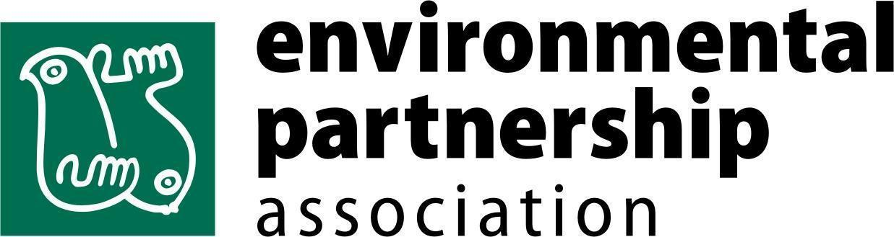
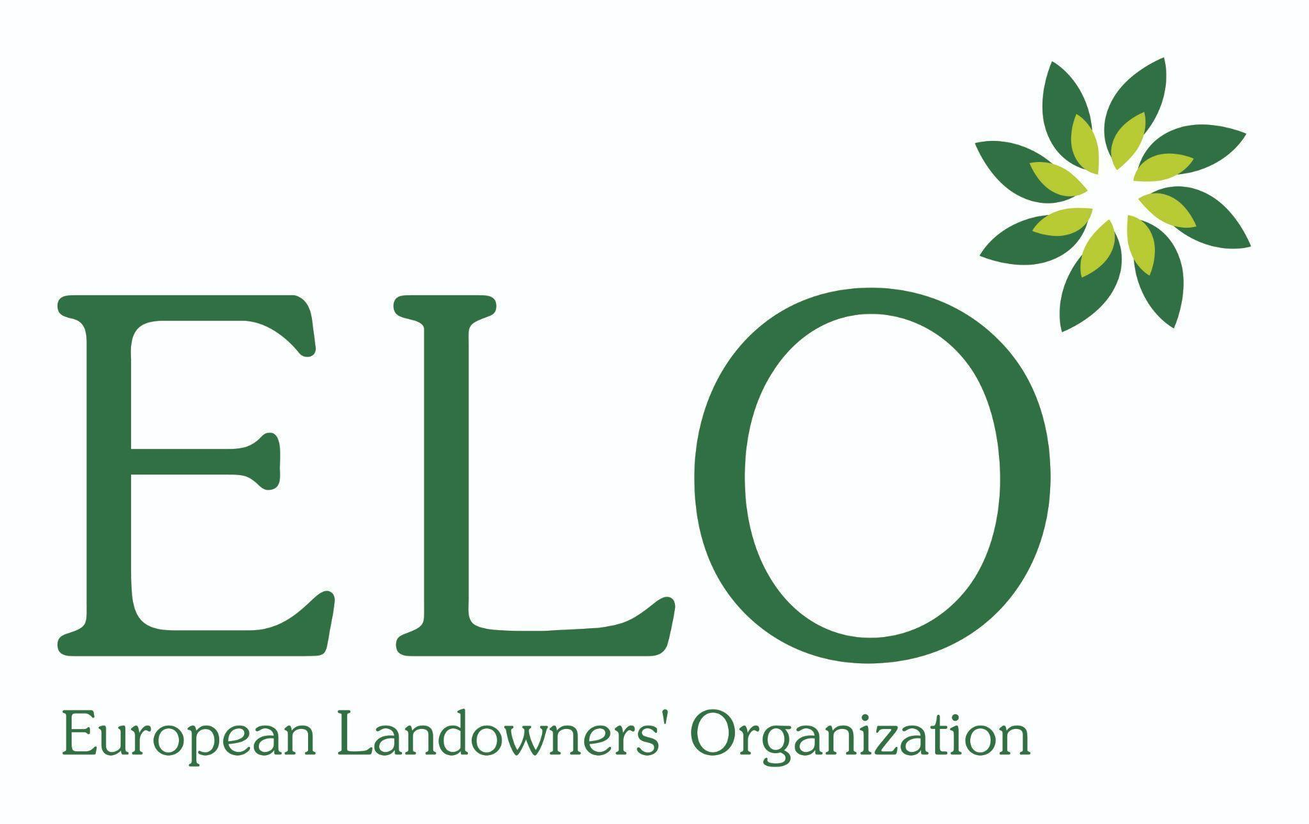

PARTNERS OF THE CONTEST:

