

**Embargo until March 19th, 19:30 pm CET**

**Polish Beech "Heart of the Dalkowskie Hills" Crowned European Tree of the Year 2025. Poland Defends Its Victory for the Fourth Time**

**(Brussels 19th of March) The beech tree “Heart of the Dalkowskie Hills” from Poland wins the title of the European Tree of the Year 2025 with 147,553 votes. The second place takes Portuguese ficus tree “The Lovers Banyan Tree,” followed by the pine tree “Pino de Juan Molinera” from Spain. Overall, an incredible 401,262 valid votes have been cast for all 15 trees in the contest in 2025.**

**The Polish beech tree** grows in the historical park in the city of Dalków. For the local community, the tree is seen as 'a heart that unites,' and tourists make wishes by throwing peanuts into a hole in the tree, believing it will make their dreams come true. This year, Poland is celebrating its fourth consecutive victory in the competition. The key to success is attributed to the local community, who nominated the tree for the contest, as well as the power of social media.

Jola Migdal from Klub Gaja, coordinator of the Tree of the Year contest in Poland, points out, *“This is our next victory in this prestigious contest and a great celebration of trees. We would like to thank everyone involved in the promotion of the Polish Beech from Dalków – the entire local community centered around this historic tree, the Polish media and all tree lovers throughout Europe. I hope that the stories of the trees taking part in the contest will inspire us to take responsible actions to protect them and preserve them for future generations.”*

The majestic **Portuguese Moreton Bay Fig**, which earned second place in the contest, was planted in the 19th century by an aristocratic tree collector as the result of seed exchanges with the Sydney Botanical Garden. Today, it stands as a beloved attraction in the Quinta das Lágrimas Gardens next to the Fountain of Lovers. The third place honors the **Pino de Juan Molinera** from Abengibre, a tree that has withstood centuries of challenges. Over the years, it has endured devastating floods, major snowstorms, and even a lightning strike, showcasing its resilience and historical significance.

The **Award Ceremony**, moderated by Mrs. Elena Visnar Malinovska and Mr. Ladislav Miko,takes place **on March 19th at the European Parliament in Brussels**. The whole ceremony is streamed and can be viewed [**at the YouTube channel of the contest**](https://www.youtube.com/watch?v=984yxGeF4vo). The two **MEPs** traditionally granting the contest their auspices, **Luděk Niedermayer,** and **Michal Wiezik**, have been joined by three distinguished patrons: **MEP Danuše Nerudová**, **MEP Nicolae Ștefănuță** and **MEP César Luena**.

MEP Michal Wiezik highlights that *“Magnificent trees with stories are the best agents for building bridges between human society and nature seeking the mutual cooperation critical for survival of both.”* This view is echoed byMEP Luděk Niedermayer, who points out: *"At times when Europe faces geopolitical challenges and security concerns, nature conservation is often seen as less urgent. However, it is precisely in such moments that we must not forget what unites us and what we must protect—our natural environment. The European Tree of the Year competition reminds us that environmental protection is not a marginal issue but a fundamental question for our future. From local initiatives, such as caring for historic trees and urban greenery, to key political decisions at the European level, we demonstrate that nature is not sidelined in our priorities. Each of these trees tells a story of the deep connection between people and the landscape—something we must never take for granted."*

The keynote address, along with the launch of a new award for those who contribute to planting 3 billion additional trees in the EU by 2030, will be delivered by a very special guest at the Award Ceremony, **Director General Florika Fink-Hooijer** of DG Environment from the European Commission.

*“The European Tree of the Year award is a powerful reminder of the deep historical, cultural, and emotional connections people across the EU have with “their” trees. While we must protect our ancient trees, we must also plant new ones to combat the climate and biodiversity crisis. That is why today, we are launching the 3 Billion Trees Award—recognising innovative and impactful tree-planting projects across Europe. This initiative is part of the EU’s ambitious commitment to plant 3 billion additional trees by 2030, in line with our EU Biodiversity and Forest Strategies for 2030. By joining forces with the European Tree of the Year organisation, we aim to inspire a new generation of environmental stewardship in every corner of the EU,”* comments Florika Fink-Hooijer.

[**Download the tree pictures here**](https://drive.google.com/drive/folders/1PoG_FuIwaQjX4lT2WF3bDRQMScpgznac)

**Media Contact:** Kateřina Bolečková: [katerina.boleckova@nadacepartnerstvi.cz](mailto:katerina.boleckova@nadacepartnerstvi.cz) — (+420) 731 013 798

**European Tree of the Year 2025 Results**

| **Standing** | **Name of the tree** | **Country** | **Votes** |
| --- | --- | --- | --- |
| 1 | [Heart of the Dalkowskie Hills](https://www.treeoftheyear.org/vote/heart-of-the-dalkowski-hills) | Poland | 147,553 |
| 2 | [The Lovers Banyan Tree](https://www.treeoftheyear.org/vote/the-lovers-banyan-tree) | Portugal | 43,427 |
| 3 | [Pino de Juan Molinera](https://www.treeoftheyear.org/vote/pino-de-juan-molinera) | Spain | 36,873 |
| 4 | [Lukavice Oak](https://www.treeoftheyear.org/vote/lukavice-oak) | Czech Republic | 35,650 |
| 5 | [Wild Pear from Bošáca](https://www.treeoftheyear.org/vote/wild-pear-from-bosaca) | Slovakia | 23,729 |
| 6 | [White Acacia](https://www.treeoftheyear.org/vote/white-acacia) | Ukraine | 16,986 |
| 7 | [The Skipinnish Oak](https://www.treeoftheyear.org/vote/the-skipinnish-oak) | United Kingdom | 16,771 |
| 8 | [Mēru Grand Oak](https://www.treeoftheyear.org/vote/meru-grand-oak) | Latvia | 13,088 |
| 9 | [Tree of Freedom in Rab](https://www.treeoftheyear.org/vote/tree-of-freedom-in-rab-square) | Croatia | 12,807 |
| 10 | [The Oak of Varniškės](https://www.treeoftheyear.org/vote/the-oak-of-varniskes) | Lithuania | 11,909 |
| 11 | [Tasso di Matari - Urzulei](https://www.treeoftheyear.org/vote/tasso-di-matari-urzulei) | Italy | 11,845 |
| 12 | [Ginkgo Biloba](https://www.treeoftheyear.org/vote/ginkgo-biloba) | The Netherlands | 9,834 |
| 13 | [The Peaceful Oak of Saint-Maurice](https://www.treeoftheyear.org/vote/the-peaceful-oak-of-saint-maurice) | France | 7,303 |
| 14 | [Plane Tree in the Archbishop's Garden](https://www.treeoftheyear.org/vote/plane-tree-in-the-archbishops-garden) | Hungary | 7,115 |
| 15 | [The Old Chestnut of Sint-Rafaël](https://www.treeoftheyear.org/vote/the-old-chestnut-of-sint-rafael) | Belgium | 6,373 |
| **TOTAL NUMBER OF VOTES** | | | **401,262** |

The **European Tree of the Year** is a contest that highlights the significance of trees in the natural and cultural heritage of Europe and the importance of the ecosystem services trees provide. The contest is not looking for the most beautiful tree, but for a tree with a story, a tree rooted in the lives and work of the people and the community that surrounds it.

[**www.treeoftheyear.org**](http://www.treeoftheyear.org)

The **Environmental Partnership Association** (EPA) is a leading environmental organisation established for almost 30 years in Central and Eastern Europe. With a team of 80 employees, the EPA operates in 6 countries via its 6-member foundations in Bulgaria, the Czech Republic, Hungary, Poland, Romania and Slovakia. The EPA boasts 30-years of experience in project coordination and carrying out activities oriented to changing people’s mind-sets in order to protect and improve the environment.

[**www.environmentalpartnership.org**](http://www.environmentalpartnership.org)

The **European Landowners' Organisation** (ELO), created in 1972, is a unique federation of national associations from the 27 EU Member States and beyond, which represents the interests of landowners, land managers and rural entrepreneurs at the European political level. Independent and non-profit making, the ELO is the only organisation able to stand for all rural entrepreneurs. The ELO promotes a prosperous countryside through private property dynamism. Its Secretariat is based in Brussels

**www.europeanlandowners.org**

**THE CONTEST IS ORGANISED BY: SUPPORT:**



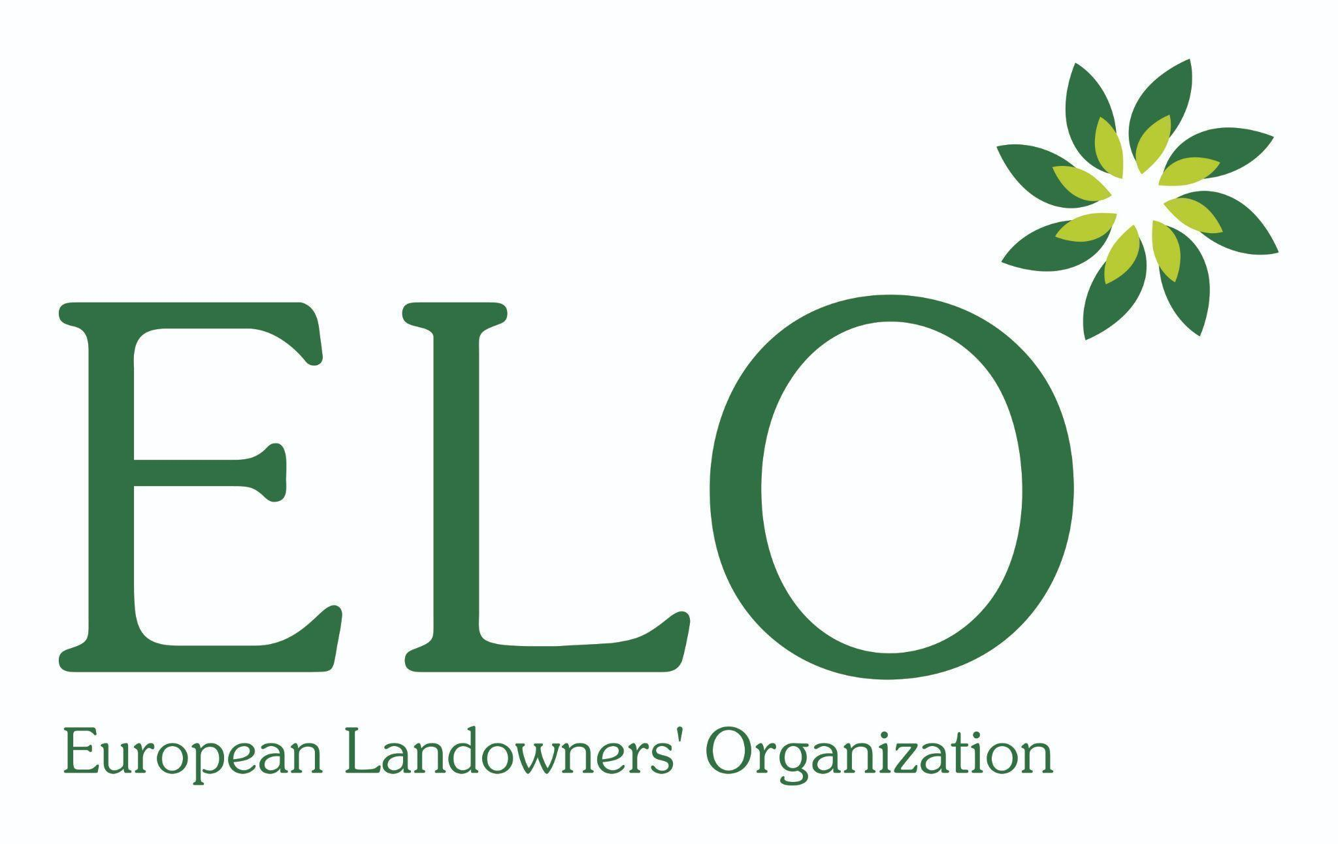

**PARTNERS OF THE AWARD CEREMONY:**





**NATIONAL CONTEST ORGANISERS:**

