PRESS RELEASE

Embargo until March 24th, 19:00 pm CET
Lithuanian "Oak of Laukiai" becomes the European Tree of the Year 2026
(Brussels 24 March) The Lithuanian Oak of Laukiai from the village of Rukai has won the 15th edition of the European Tree of the Year contest. The Old Wild Apple Tree from Slovakia takes second place, while the Crooked Tree from Poland ranks third. The new Tree Points system brought overall 32,902 points, cast by more than 200,000 unique voters.
The 400 year old Oak of Laukiai once stood almost forgotten, known only to the people of the small Rukai village. A year ago, however, the local community restored the area around the tree and organised a celebration in its honour, bringing people together and reminding them of its quiet strength. Today, the sixth generation of the Laukiai people is growing up alongside this oak.
The Old Wild Apple Tree, which placed second, has withstood wind, rain, snowstorms, and heat waves for more than 150 years, growing in harsh conditions at an altitude of 860 meters. From a place called Diel, it quietly watches over the village below – a silent observer of its joys, troubles, and changes. The third placed Crooked Elm of Szyslowiec rises above the moat on an island near the former castle of the Szydłowiecki and Radziwiłł families. Its unusual shape comes from its location, forcing it to lean toward the water.
This year, for the first time, the trees competed for Tree points instead of votes."The competition was extremely close – the ranking remained uncertain until the very last moment. This year’s magnificent trees attracted huge attention across Europe. During the voting period, the website recorded around 1.5 million visits, with more than 200,000 unique voters – people who care about nature and the environment,” evaluates this years contest Petr Skrivanek, Coordinator of the European Tree of the Year.
The Award Ceremony, moderated by Mrs. Natalie Pauwels and Mr. Ladislav Miko, takes place on March 24th at the European Parliament in Brussels. The whole ceremony is streamed live on the YouTube channel of the contest.
The keynote address will be delivered by a very special guest at the Award Ceremony, Eric Mamer, Director-General for Environment at the European Commission. The event is held under the auspices of three Members of the European Parliament: Danuše Nerudová, Luděk Niedermayer and Michal Wiezik.
MEP Michal Wiezik (Renew Europe) highlights that: "Old, magnificent trees are like silent pillars of our time. They stand firm where the world around them changes in a fast and unpredictable gallop. In their rings lies the memory of the landscape and of society, reminding us all that true stability does not arise from haste, but from patient and quiet growth. When we care for them, we are not only protecting nature, but also our own ability to stay rooted in unsettled times and to remember all the days that have shaped our present.”
The partners of the European Tree of the Year are also Škoda Auto Endowment Fund, the Czech Ministry of the Environment and the State Environmental Fund of the Czech Republic.
“Strong public engagement in the European Tree of the Year contest voting indicates that trees are not only an integral part of the landscape, but are also perceived as bearers of stories, local identity, continuity, and people’s connection to nature. This topic is particularly close to the State Environmental Fund of the Czech Republic, which has long supported tree planting and the care of landscape elements that are essential for the ecological stability of the landscape as well as for quality of life,” says Petr Valdman, the Director of the State Environmental Fund of the Czech Republic.
Download the tree pictures HERE
Download stories of the trees HERE

Media Contact: Petr Skřivánek: petr.skrivanek@nadacepartnerstvi.cz – (+420) 776 662 256

European Tree of the Year 2026 Results

Standing | Name of the tree | Country | Tree Points
1 | Oak of Laukiai | Lithuania | 6 153
2 | Old Wild Apple Tree | Slovakia | 4 766
3 | Crooked Tree | Poland | 4 720
4 | Linden of Sacrifice | Latvia | 4 653
5 | Kostrena Oak Tree | Croatia | 3 252
6 | Cedro de Runa | Portugal | 3 058
7 | Oak of Prince Ulrich | Czech Republic | 2 325
8 | Tree of Memories | Hungary | 1 348
9 | Ancient Ginkgo of St-Hilaire | France | 762
10 | Ledeboerpark Giant Sequoia | The Netherlands | 735
11 | Sophora from Prymorsky park | Ukraine | 594
12 | Argyle Street Ash | United Kingdom | 536
TOTAL NUMBER OF TREE POINTS |  |  | 32 902

The European Tree of the Year is a contest that highlights the significance of trees in the natural and cultural heritage of Europe and the importance of the ecosystem services trees provide. The contest is not looking for the most beautiful tree, but for a tree with a story, a tree rooted in the lives and work of the people and the community that surrounds it.
www.treeoftheyear.org

The Environmental Partnership Association (EPA) is a leading environmental organisation established for almost 30 years in Central and Eastern Europe. With a team of 80 employees, the EPA operates in 6 countries via its 6-member foundations in Bulgaria, the Czech Republic, Hungary, Poland, Romania and Slovakia. The EPA boasts 30-years of experience in project coordination and carrying out activities oriented to changing people’s mind-sets in order to protect and improve the environment.
www.environmentalpartnership.org

The European Landowners' Organisation (ELO), created in 1972, is a unique federation of national associations from the 27 EU Member States and beyond, which represents the interests of landowners, land managers and rural entrepreneurs at the European political level. Independent and non-profit making, the ELO is the only organisation able to stand for all rural entrepreneurs. The ELO promotes a prosperous countryside through private property dynamism. Its Secretariat is based in Brussels
www.europeanlandowners.org

THE CONTEST IS ORGANISED BY: SUPPORT:

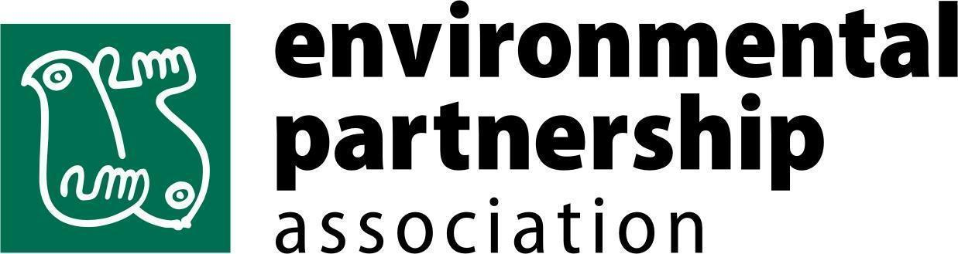
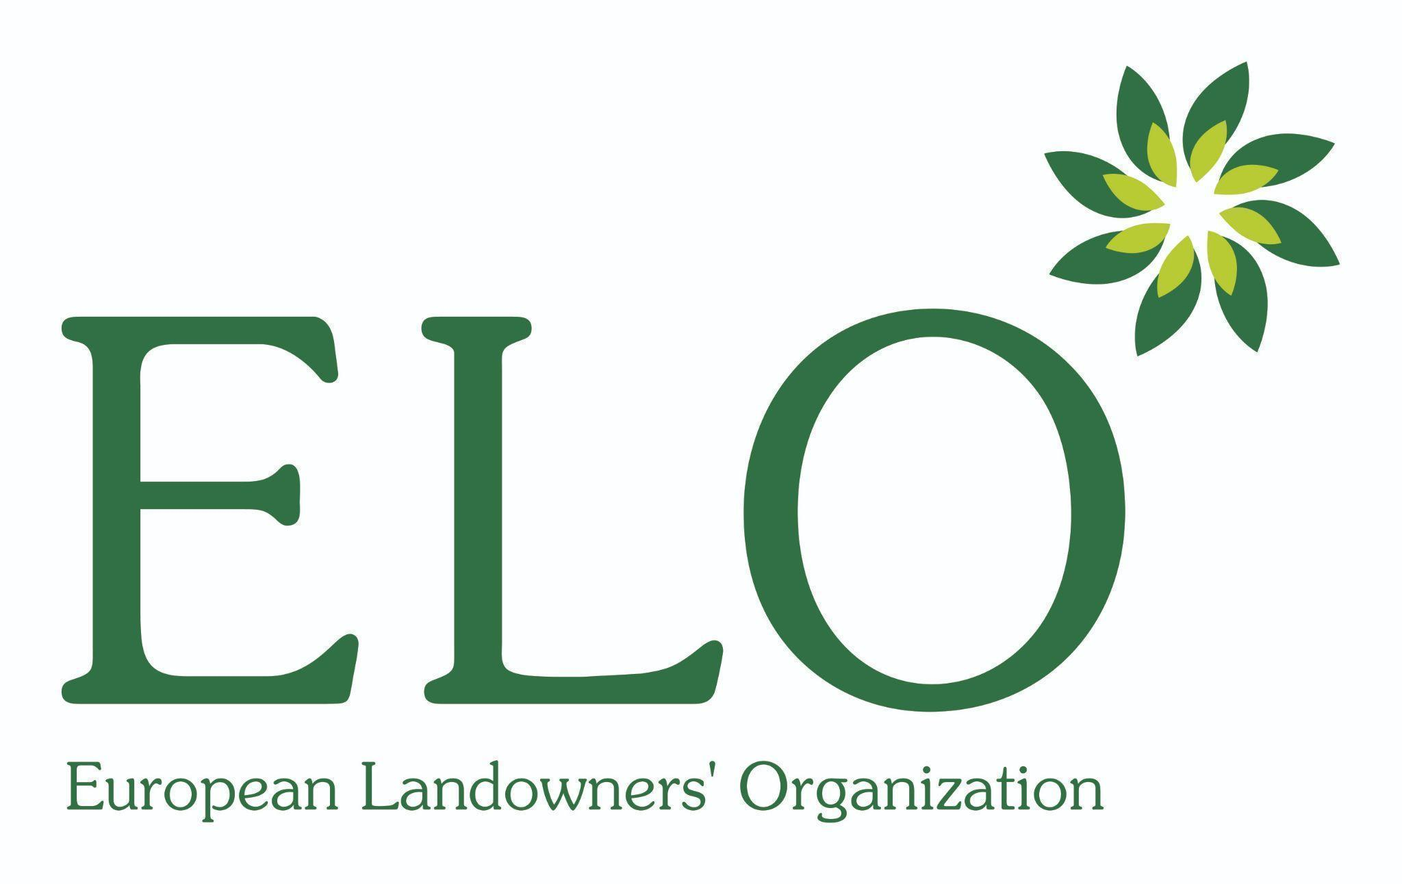

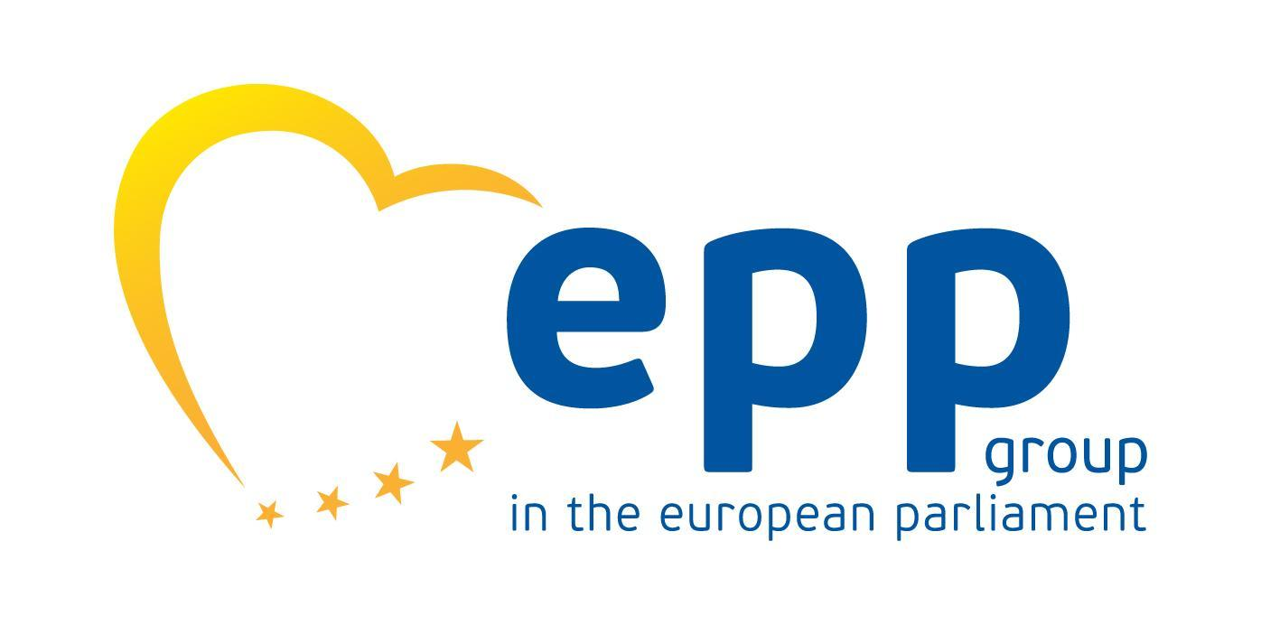
PARTNERS OF THE CONTEST AND THE AWARD CEREMONY:





