PRESS RELEASE
Embargo until Wednesday March 20th, 20:00 pm CET
The Polish beech “Heart of Garden” won the hearts of Europeans. It becomes this year's European Tree of the Year with 39,158 votes

(Brussels 20th of March) In 2024, the Polish beech Heart of Garden from the Niemcza region wins the European Tree of the Year contest. Yet another beech tree takes the second place: The Weeping Beech of Bayeux from Normandy, France. An honourable third place goes to The Thousand-year-old Olive Tree of Luras from Sardinia, Italy.
Overall, 174,112 valid votes have been cast in ETY 2024. Even though the first preliminary results showed the French beech in the lead, it is the Polish beech that has been crowned the European Tree of the Year. It is also a Polish hat-trick as it is the third Polish tree in a row to win the contest. The third place has been taken by the ancient olive from Italy which narrowly beat the curiously shaped common camellia from Portugal. The Heart of Garden grows in the centre of an old park. Its majestic appearance impresses with its unusually shaped and thick trunk, widely spread branches, and purple-coloured leaves. It is a living proof of an old park’s historic turmoil and dominates over the Arboretum situated around it.
The Award Ceremony takes place in the European Parliament on March 20th from 18:30 under the patronage of Commissioner Virginijus Sinkevičius, MEP Luděk Niedermayer (EPP), and MEP Michal Wiezik (Renew). The event will be traditionally streamed here. Though the Commissioner could not attend the ceremony in person, he has pre-recorded a video greeting.
This year's Award Ceremony is held at a special place inside the European Parliament: the Yehudi Menuhin amphitheatre. It is perhaps the most prestigious space in the parliamentary complex and an exhibition showing all the finalist trees will stay there until Friday. This year also brings a change regarding the hosts of the evening. Natalie Pauwels is joined by Elena Visnar Malinovska for the first time, both from the European Commission, thereby replacing the traditional co-host Ladislav Miko, who sends his greetings to the supporters of the contest from his travels in South America.
This year's contest is organised in partnership with the Ministry of the Environment of the Czech Republic and the State Environmental Fund of the Czech Republic. “I am delighted that we have sent the winner of the Czech version of the survey to the international competition European Tree of the Year. The “Nadace Partnerství” organises it every year with the aim of highlighting our trees with interesting stories. Creating a relationship with nature is essential for its protection. This is what the project "Sázíme budoucnost", which is implemented by the “Nadace Partnerství” with the financial support of the Ministry of the Environment, is trying to do. As a result, more than 4.3 million trees have already been planted in our landscape. In addition, our Ministry is intensively involved in the legislative protection of trees. Trees should be treated as natural and cultural heritage," said Minister of the Environment Petr Hladík (KDU-ČSL). The State Environmental Fund of the Czech Republic will be represented at the Award Ceremony by Mr Michal Slezák, Director of the National Programmes.
Download the tree pictures here

Media Contacts:
Adam Holub, Brussels Representative: adam.holub@nap.cz
European Tree of the Year 2024: results
Standing | Name | Country | Votes
1 | Heart of Garden | Poland | 39,158
2 | The Weeping Beech of Bayeux | France | 24,807
3 | The Thousand-year-old Olive Tree of Luras | Italy | 13,933
4 | Camellia | Portugal | 13,508
5 | Pear Tree in the Middle of a Field | Czech Republic | 10,433
6 | The Spanish Oak of La Vega | Spain | 9,995
7 | The Maria Lime | The Netherlands | 9,976
8 | The Millennium Oak | Ukraine | 8,886
9 | Kaņepju Oak | Latvia | 8,149
10 | Wrexham's Acton Park Sweet Chestnut | United Kingdom | 7,180
11 | Lithuania’s Patriarch Tree | Lithuania | 6,656
12 | The Viiralt's Oak | Estonia | 5,703
13 | The Green Lady of the Krka National Park | Croatia | 5,690
14 | An Oak That Remembers the Pálffy Family | Slovakia | 5,204
15 | The Cedar of the Sainte-Marie college | Belgium | 4,834
Total number of votes: |  |  | 174,112

The Environmental Partnership Association (EPA) is a leading environmental organization established for almost 30 years in Central and Eastern Europe. The EPA operates in 6 countries via its 6-member foundations in Bulgaria, the Czech Republic, Hungary, Poland, Romania and Slovakia. The EPA boasts 30-years of experience in project coordination and carrying out activities oriented to changing people’s mind-sets in order to protect and improve the environment.
www.environmentalpartnership.org

The European Landowners' Organization (ELO), created in 1972, is a unique federation of national associations from EU Member States and beyond, which represents the interests of landowners, land managers and rural entrepreneurs at the European political level. Independent and non-profit making, the ELO is the only organization able to stand for all rural entrepreneurs. The ELO promotes a prosperous countryside through private property dynamism. Its Secretariat is based in Brussels.
www.europeanlandowners.org

The European Tree of the Year is a contest that highlights the significance of trees in the natural and cultural heritage of Europe and the importance of the ecosystem services trees provide. The contest is not looking for the most beautiful tree, but for a tree with a story, a tree rooted in the lives and work of the people and the community that surrounds it.
www.treeoftheyear.org

THE CONTEST IS ORGANISED BY: SUPPORT:

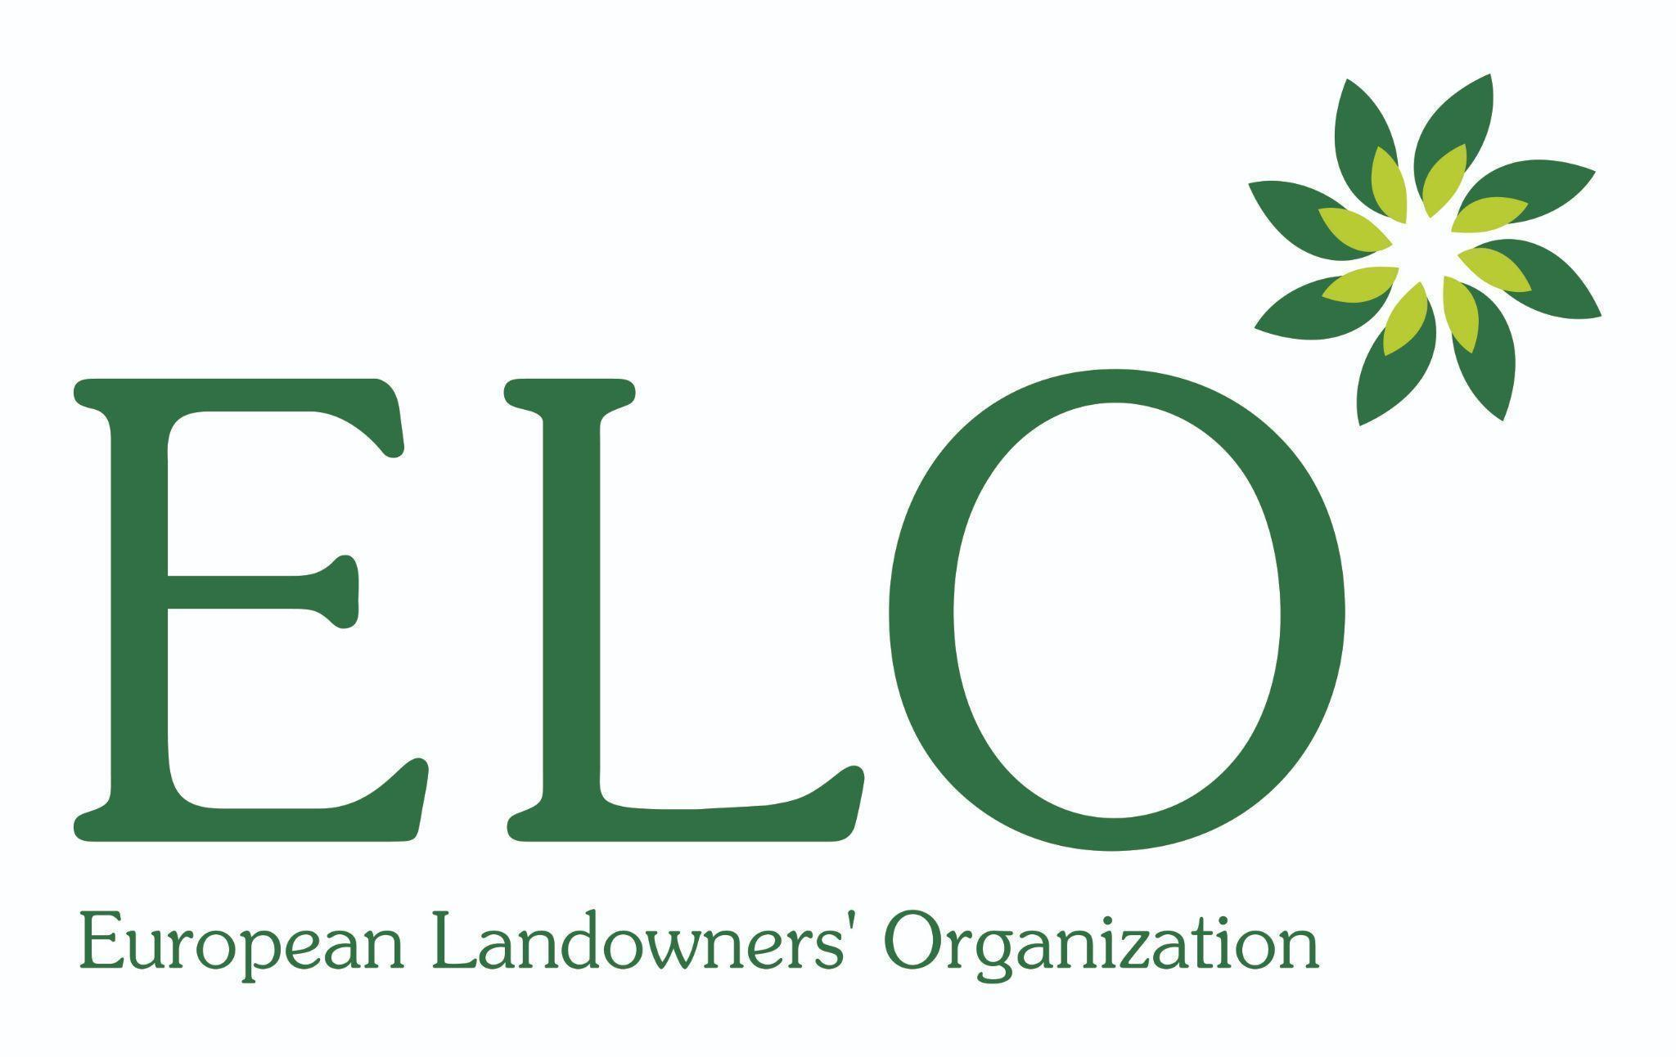

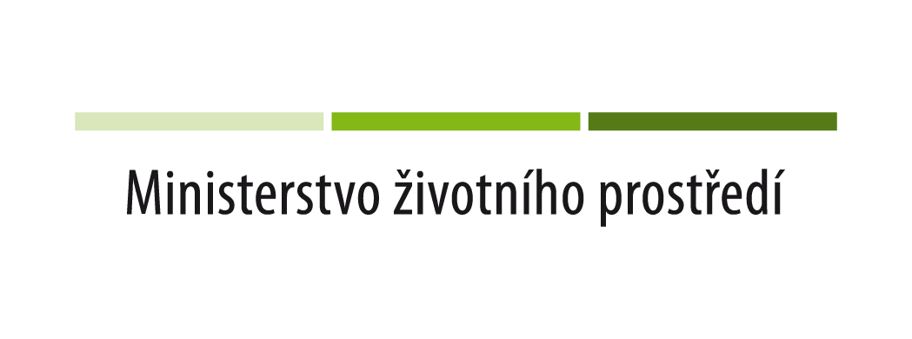
PARTNERS OF THE AWARD CEREMONY:

NATIONAL CONTEST ORGANISERS:
