PRESS RELEASE

Race of the beech trees: one week before the end of voting, the Polish Heart of the Garden beech takes over The Weeping Beech of Bayeux to lead in the European Tree of the Year 2024!
Brussels, February 15th 2024,
One week has passed since the last announcement of the current standing in the ETY 2024. The contest now sees The Heart of the Garden in the lead followed by The Weeping Beech of Bayeux and The Thousand-year-old Olive Tree of Luras one week before the end of the vote. Europeans can still vote in the final week until February 22nd, 4:00 PM CET, at www.treeoftheyear.org.
As the vote in ETY 2024 is moving into its final week, we see a shuffle at the top of the table. The Weeping Beech of Bayeux from France with 13,753 votes has swapped places with the Polish Heart of the Garden which is currently leading the peloton with 21,808 votes. The Thousand-year-old Olive Tree of Luras from Italy with 8,812 is currently third. The change of positions correlates with the intensification of the online campaign in support of the finalist trees. The complete table of the current standing can be found at the bottom of this press release.
One of the key themes of ETY is the relationship local communities have with their natural environment. This year, the contest is supported by the Czech Ministry of the Environment, which traditionally plays a positive role supporting this relationship. "The Ministry of the Environment of the Czech Republic has long been trying to strengthen the relationship between local communities and their natural treasures, whether through subsidies for, among other things, planting community green spaces, restoring and creating landscape features, and our recent research project on community gardens in cities to determine their potential in times of crisis such as the COVID pandemic. The importance of community gardens, which offer a space for relaxation, a green island in times of heat, a haven for urban biodiversity and food sovereignty, will grow in the future, and we therefore want to support them,” explains Petr Hladík, Czech Minister for the Environment.
Preparations for the award ceremony on March 20th in the European Parliament, PAUL - HENRI SPAAK building, Floor 1, YEHUDI MENUHIN amphitheatre are advancing. “Alongside the voting, we are busy with preparing the Award Ceremony. I am responsible for liaising between the organisers of the event and EU institutions and I can now confidently say that this year will enjoy a particularly high level of recognition from the ranks of the EU's policy makers. More details on this will come with the “save-the-date” followed by an official invitation to the event which we will send out at the end of February,” hints Adam Holub, the Brussels representative of the Czech Environmental Partnership Foundation.
Download the tree pictures here
Key dates:
- 1. – 22. 2. 2024: Secret voting open at www.treeoftheyear.org/vote
- 20. 3. 2024: Award Ceremony at the European Parliament, PAUL-HENRI SPAAK building, Floor 1, YEHUDI MENUHIN amphitheatre
Media Contacts:
Adam Holub: adam.holub@nadacepartnerstvi.cz — (+420) 777 053 722

Ranking at 22:00 CET on February 14th:

Rank | Name of the tree | Country | Number of votes
1. | The Heart of the Garden | Poland | 21,808
2. | The Weeping Beech of Bayeux | France | 13,753
3. | The Thousand-year-old Olive Tree of Luras | Italy | 8,812
4. | Camellia | Portugal | 6,925
5. | Pear Tree in the Middle of a Field | Czech Republic | 6,257
6. | The Maria Lime | Netherlands | 5,934
7. | The Spanish Oak of La Vega | Spain | 5,564
8. | The Millennium Oak | Ukraine | 4,908
9. | Kaņepju Oak | Latvia | 4,470
10. | Wrexham's Acton Park Sweet Chestnut | United Kingdom | 4,085
11. | The Green Lady of the Krka National Park | Croatia | 3,778
12. | The Viiralt's Oak | Estonia | 3,262
13. | The Cedar of the Sainte-Marie college | Belgium | 2,851
14. | An Oak That Remembers the Pálffy Family | Slovakia | 2,850
15. | Lithuania’s Patriarch Tree | Lithuania | 2,785
TOTAL NUMBER OF VOTES |  |  | 98,042

The European Tree of the Year is a contest that highlights the significance of trees in the natural and cultural heritage of Europe and the importance of the ecosystem services trees provide. The contest is not looking for the most beautiful tree, but for a tree with a story, a tree rooted in the lives and work of the people and the community that surrounds it.
www.treeoftheyear.org

The Environmental Partnership Association (EPA) is a leading environmental organisation established for almost 30 years in Central and Eastern Europe. With a team of 80 employees, the EPA operates in 6 countries via its 6-member foundations in Bulgaria, the Czech Republic, Hungary, Poland, Romania and Slovakia. The EPA boasts 30-years of experience in project coordination and carrying out activities oriented to changing people’s mind-sets in order to protect and improve the environment.
www.environmentalpartnership.org

The European Landowners' Organisation (ELO), created in 1972, is a unique federation of national associations from the 27 EU Member States and beyond, which represents the interests of landowners, land managers and rural entrepreneurs at the European political level. Independent and non-profit making, the ELO is the only organisation able to stand for all rural entrepreneurs. The ELO promotes a prosperous countryside through private property dynamism. Its Secretariat is based in Brussels
www.europeanlandowners.org

THE CONTEST IS ORGANISED BY: SUPPORT:

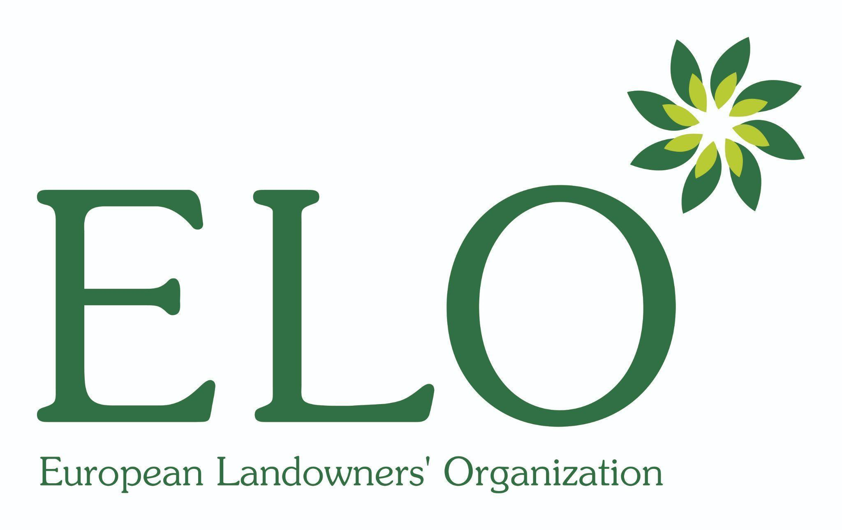

PARTNERS OF THE CONTEST:

NATIONAL CONTEST ORGANISERS:
