PRESS RELEASE

The European Tree of the Year 2024 voting is in full swing! The preliminary standing shows a French tree in the lead.
Brussels, February 8th 2024,
The voting in the European Tree of the Year contest has been in full course since February 1st and the first preliminary standings see a tree from France in the lead followed by Poland and Italy. Europeans can vote until February 22nd at www.treeoftheyear.org.
Since February 1st, Europeans can vote in the 2024 European Tree of the Year (ETY) contest on the award's website. First Europeans have already cast their votes. In accordance with the new rules of the contest, the current standing is shared twice during the voting which is otherwise secret. The current ranking sees The Weeping Beech of Bayeux from France in the lead followed by the Polish beech tree called The Heart of the Garden and The Thousand-year-old Olive Tree of Luras from Italy. So far 43,888 votes have been cast in this year's competition. See the full table with rankings below.
After the revelation of the preliminary standing, MEP Michal Wiezik (Renew) who is a patron of the European Tree of the Year notes: “Trees represent a significant element of our everyday life, our physical environment, but are also magnificent beings closely related to our inner space, culture and history. As the essence of forest, they deliver critical ecosystem services, but they are also the agents for bridging human society and nature, our presence and history, as well as our companions into sustainable and planet compatible future. I am always very touched by the beauty and deep stories of each finalist tree, and looking forward to see also this year's winner of the contest.”
This year's event found a new partner in the Ministry of the Environment of the Czech Republic. Miroslav Kundrata, Strategic Director of the Czech Environmental Partnership Foundation, says: “It is very important for us to have such an esteemed partner as the Czech Ministry of the Environment on board. Already during the Czech presidency a year ago, but also in months that followed, the Czech voice in the European debate has been one that champions the protection of nature and care for our beloved trees.” Miroslav Kundrata also points out: “This year, the trees competing are quite exceptional not only in age but also in species diversity. This shows Europe in the best light with all its regional richness, local climatic differences, and diverse ecosystems. It is also a reminder that the preservation of biodiversity is a key challenge of our generation.”
The award Ceremony will take place on March 20th in the European Parliament, PAUL - HENRI SPAAK building, YEHUDI MENUHIN amphitheatre in what will be yet another precious event that allows representatives of local communities to meet face to face with top European decision makers. MEP Michal Wiezik (Renew), whose team traditionally actively helps ensure the smooth organisation of the event, adds: “The ceremony is always a great opportunity to not only celebrate the winners but to meet great people from all around Europe, who care for the magnificent trees. I am always pleased to see that their authentic interest and devotions for trees and their protection go far beyond the particular contest. It is a celebration of beautiful symbiosis between man and tree.”

Key dates:
- 1. – 22. 2. 2024: Secret voting open at www.treeoftheyear.org/vote
- 15. 2. 2024: 2nd press release with the current vote counts and standing
- 20. 3. 2024: Award Ceremony at the European Parliament, PAUL-HENRI SPAAK building, Floor 1, YEHUDI MENUHIN amphitheatre
Media Contacts:
Adam Holub: adam.holub@nadacepartnerstvi.cz — (+420) 777 053 722

Ranking at 22:00 CET on February 7th:

Rank | Name of the tree | Country | Number of votes | Competition number of the tree in contest
1. | The Weeping Beech of Bayeux | France | 7,429 | 14
2. | The Heart of the Garden | Poland | 6,675 | 8
3. | The Thousand-year-old Olive Tree of Luras | Italy | 4,287 | 12
4. | Pear Tree in the Middle of a Field | Czech Republic | 3,504 | 5
5. | Camellia | Portugal | 3,360 | 2
6. | The Maria Lime | Netherlands | 3,105 | 9
7. | The Spanish Oak of La Vega | Spain | 2,684 | 11
8. | Kaņepju Oak | Latvia | 2,071 | 3
9. | The Millennium Oak | Ukraine | 2,007 | 10
10. | Wrexham's Acton Park Sweet Chestnut | United Kingdom | 1,905 | 15
11. | The Green Lady of the Krka National Park | Croatia | 1,683 | 7
12. | An Oak That Remembers the Pálffy Family | Slovakia | 1,631 | 1
13. | The Viiralt's Oak | Estonia | 1,375 | 13
14. | Lithuania’s Patriarch Tree | Lithuania | 1,185 | 4
15. | The Cedar of the Sainte-Marie college | Belgium | 987 | 6
TOTAL NUMBER OF VOTES |  |  | 43,888

The European Tree of the Year is a contest that highlights the significance of trees in the natural and cultural heritage of Europe and the importance of the ecosystem services trees provide. The contest is not looking for the most beautiful tree, but for a tree with a story, a tree rooted in the lives and work of the people and the community that surrounds it.
www.treeoftheyear.org

The Environmental Partnership Association (EPA) is a leading environmental organisation established for almost 30 years in Central and Eastern Europe. With a team of 80 employees, the EPA operates in 6 countries via its 6-member foundations in Bulgaria, the Czech Republic, Hungary, Poland, Romania and Slovakia. The EPA boasts 30-years of experience in project coordination and carrying out activities oriented to changing people’s mind-sets in order to protect and improve the environment.
www.environmentalpartnership.org

The European Landowners' Organisation (ELO), created in 1972, is a unique federation of national associations from the 27 EU Member States and beyond, which represents the interests of landowners, land managers and rural entrepreneurs at the European political level. Independent and non-profit making, the ELO is the only organisation able to stand for all rural entrepreneurs. The ELO promotes a prosperous countryside through private property dynamism. Its Secretariat is based in Brussels
www.europeanlandowners.org

THE CONTEST IS ORGANISED BY: SUPPORT:

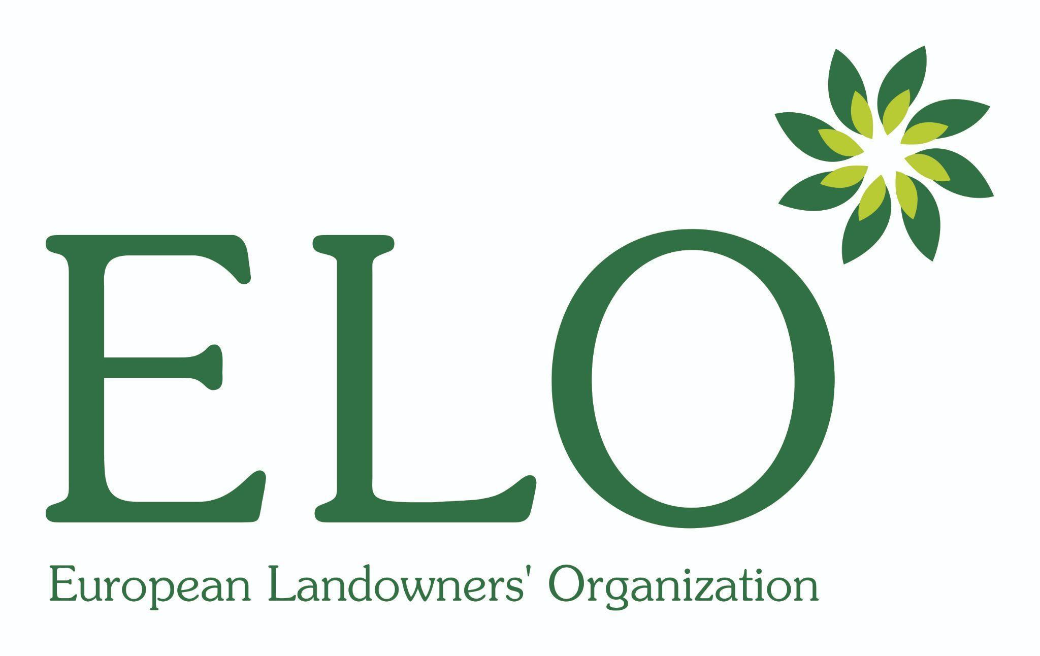

PARTNERS OF THE CONTEST:
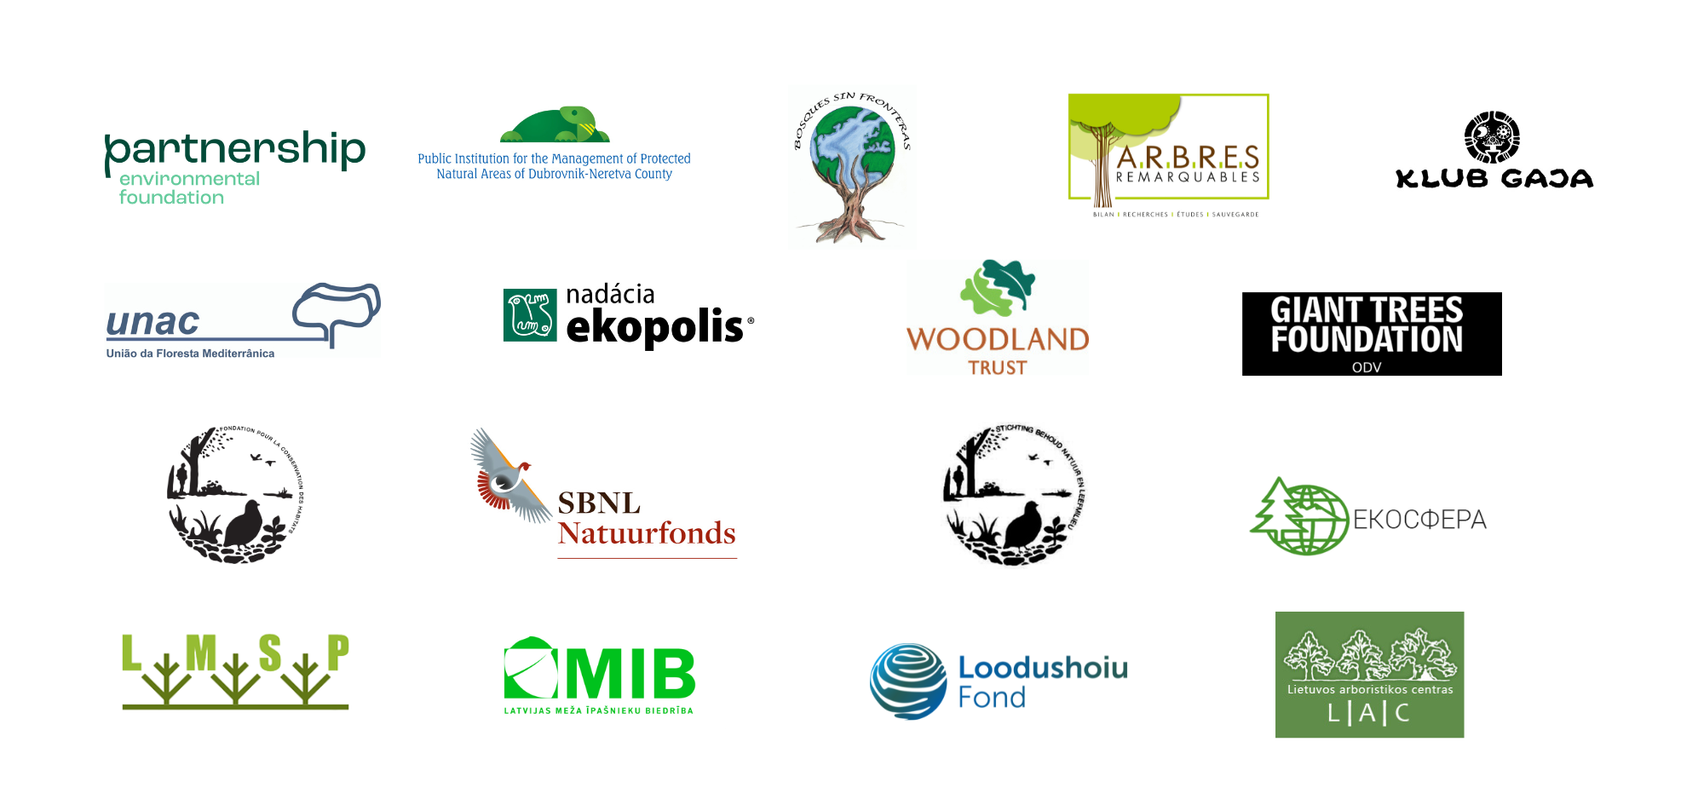
NATIONAL CONTEST ORGANISERS:

