

**Voting for the European Tree of the Year 2025 just started! With Hungary back in the race**

**The voting for the European Tree of the Year has officially begun today, marking the launch of the 14th edition of the contest. The competition searches for trees with unique stories and strong connections to local communities. This year, 15 countries are participating, with Hungary returning after a one-year break. Online voting is open from February 3rd to February 24th at** [**www.treeoftheyear.org**](http://www.treeoftheyear.org)**.**

On Monday February 3rd, the Environmental Partnership Foundation on behalf of the Environmental Partnership Association with the support of the European Landowners' Organisation launched the final vote in the 2025 European Tree of the Year contest on the [website](https://www.treeoftheyear.org/). The full list of this year’s contestants and their stories is available at [www.treeoftheyear.org/vote](http://www.treeoftheyear.org/vote). **Voting is open to the public** **from Monday February 3rd 8:00 CET until Monday February 24th 16:00 CET.** The current **vote counts will be hidden throughout the whole period** **of voting** and will be officially **revealed at the Award Ceremony**.

The roots of the competition trace back to the Czech Republic, where the Environmental Partnership Foundation organized the first nationwide vote for the most impressive tree in 2002. The idea inspired other European countries. *“This year we are launching the 14th edition of the European Tree of the Year competition, with 15 participating countries, including Hungary, which returns after a one-year hiatus and has already won the competition four times in its history. The purpose of the competition is to raise awareness about the importance of tree care. Trees are witnesses to our history, and their shade will hopefully be enjoyed by generations to come. We believe that, despite differences in cultures, languages, or political views, trees can serve as a symbol that unites us,”* says Kateřina Bolečková, the Contest Coordinator.

This year’s European Tree of the Year competition features 15 remarkable trees, each with a unique story. The **Ginkgo Biloba** in the **Netherlands** is one of Europe’s oldest, symbolizing love and hope; **Poland’s Heart of the Dalkowskie Hills** is a beloved community gathering spot. **Lukavice Oak** in the **Czech Republic,** **Latvian** **Mēru Grand Oak,** and **Spanish Pino de Juan Molinera** have withstood centuries of history. **Hungarian Plane tree** is steeped in tradition, while the ancient **yew** representing **Italy** and **Portugal’s Lovers Banyan Tree** symbolize endurance and romance. **The Oak of Varniškės** in **Lithuania** unites past and future generations, the **Chestnut of Sint-Rafaël** in **Belgium** represents local heritage and  **the Peaceful Oak of Saint-Maurice** in **France** invites introspection. **The Skipinnish Oak** in the **UK**, **Croatian Tree of Freedom**, **Ukraine’s White Acacia**, and **Slovakia’s Wild Pear** each carry rich cultural and natural significance, from historical events to modern-day traditions.

The **Award Ceremony** of the contest will take place **on March 19th in the European Parliament, PAUL - HENRI SPAAK building, Floor 1, YEHUDI MENUHIN amphitheatre**. This year’s ceremony will be traditionally held under the patronage of MEPs Luděk Niedermayer and Michal Wiezik. Additionally, the ceremony is now supported by **MEP César Luena, MEP Nicolae Ștefănuță, and MEP Danuše Nerudová**.

*"The European Tree of the Year has an emotional value for me, ever since The Singing Lime Tree from my beloved village of Telecí, whose natural environment I love very much, or the Guardian of the Flooded Village in Chudobín, which carries a touching message from times forever lost, competed in this contest in previous years. Their stories are magical. The landscape around them gives me strength, just as the many places where this year's finalist trees are located give strength to the local people. I myself have been already aware of the value of the message of the contest, i.e. the message about the importance of the relationship between people and their environment, as the rector of Mendel University which under my leadership supported and still supports this great enlightening venture. I am delighted to be able to return to work on this project now as a Member of the European Parliament, "* says Danuše Nerudová, one the new MEP patrons of the contest.

MEP César Luena, who this year also became the new ambassador of the competition, comments:*"Trees are more than just nature; they are witnesses to our history, guardians of the present, and hope for the future. They teach us to endure, to grow with strength, and to share without asking for anything in return. Protecting them is protecting life itself. That is why I am so proud to be an ambassador for such a well-established and meaningful competition as the European Tree of the Year, which not only celebrates the beauty and uniqueness of each tree but also the connection between trees, forests, and our communities, and their fundamental role in the harmony of ecosystems, where plants, animals, and people depend on each other. Trees sustain life in all its forms, and it is our duty to protect them for future generations."*

[**Download the tree pictures here**](https://drive.google.com/drive/folders/1PoG_FuIwaQjX4lT2WF3bDRQMScpgznac)

[**Download stories of the trees here**](https://docs.google.com/spreadsheets/d/1MLUtzan7u4MN1v4gFgXJMMwSKuXH67FN9z8HKiTx9vE/edit?gid=0#gid=0)

**Key dates:**

* 3. – 24. 2. 2025: **Secret voting open at** [**www.treeoftheyear.org**](http://www.treeoftheyear.org)
* 19. 3. 2025: **Award Ceremony at the European Parliament, PAUL-HENRI SPAAK building, Floor 1, YEHUDI MENUHIN amphitheatre**

**Media Contact:**

Kateřina Bolečková: [katerina.boleckova@nadacepartnerstvi.cz](mailto:katerina.boleckova@nadacepartnerstvi.cz) — (+420) 731 013 798

**Finalists of the European Tree of the Year 2025**

| **Competition number** | **Name of the tree** | **Country** |
| --- | --- | --- |
| 1 | [Ginkgo Biloba](https://www.treeoftheyear.org/vote/ginkgo-biloba) | The Netherlands |
| 2 | [Heart of the Dalkowskie Hills](https://www.treeoftheyear.org/vote/heart-of-the-dalkowski-hills) | Poland |
| 3 | [Lukavice Oak](https://www.treeoftheyear.org/vote/lukavice-oak) | Czech Republic |
| 4 | [Mēru Grand Oak](https://www.treeoftheyear.org/vote/meru-grand-oak) | Latvia |
| 5 | [Pino de Juan Molinera](https://www.treeoftheyear.org/vote/pino-de-juan-molinera) | Spain |
| 6 | [Plane Tree in the Archbishop's Garden](https://www.treeoftheyear.org/vote/plane-tree-in-the-archbishops-garden) | Hungary |
| 7 | [Tasso di Matari - Urzulei](https://www.treeoftheyear.org/vote/tasso-di-matari-urzulei) | Italy |
| 8 | [The Lovers Banyan Tree](https://www.treeoftheyear.org/vote/the-lovers-banyan-tree) | Portugal |
| 9 | [The Oak of Varniškės](https://www.treeoftheyear.org/vote/the-oak-of-varniskes) | Lithuania |
| 10 | [The Old Chestnut of Sint-Rafaël](https://www.treeoftheyear.org/vote/the-old-chestnut-of-sint-rafael) | Belgium |
| 11 | [The Peaceful Oak of Saint-Maurice](https://www.treeoftheyear.org/vote/the-peaceful-oak-of-saint-maurice) | France |
| 12 | [The Skipinnish Oak](https://www.treeoftheyear.org/vote/the-skipinnish-oak) | UK |
| 13 | [Tree of Freedom in Rab](https://www.treeoftheyear.org/vote/tree-of-freedom-in-rab-square) | Croatia |
| 14 | [White Acacia](https://www.treeoftheyear.org/vote/white-acacia) | Ukraine |
| 15 | [Wild Pear from Bošáca](https://www.treeoftheyear.org/vote/wild-pear-from-bosaca) | Slovakia |

The **European Tree of the Year** is a contest that highlights the significance of trees in the natural and cultural heritage of Europe and the importance of the ecosystem services trees provide. The contest is not looking for the most beautiful tree, but for a tree with a story, a tree rooted in the lives and work of the people and the community that surrounds it.

[**www.treeoftheyear.org**](http://www.treeoftheyear.org)

The **Environmental Partnership Association** (EPA) is a leading environmental organisation established for almost 30 years in Central and Eastern Europe. With a team of 80 employees, the EPA operates in 6 countries via its 6-member foundations in Bulgaria, the Czech Republic, Hungary, Poland, Romania and Slovakia. The EPA boasts 30-years of experience in project coordination and carrying out activities oriented to changing people’s mind-sets in order to protect and improve the environment.

[**www.environmentalpartnership.org**](http://www.environmentalpartnership.org)

The **European Landowners' Organisation** (ELO), created in 1972, is a unique federation of national associations from the 27 EU Member States and beyond, which represents the interests of landowners, land managers and rural entrepreneurs at the European political level. Independent and non-profit making, the ELO is the only organisation able to stand for all rural entrepreneurs. The ELO promotes a prosperous countryside through private property dynamism. Its Secretariat is based in Brussels

**www.europeanlandowners.org**

**THE CONTEST IS ORGANISED BY: SUPPORT:**



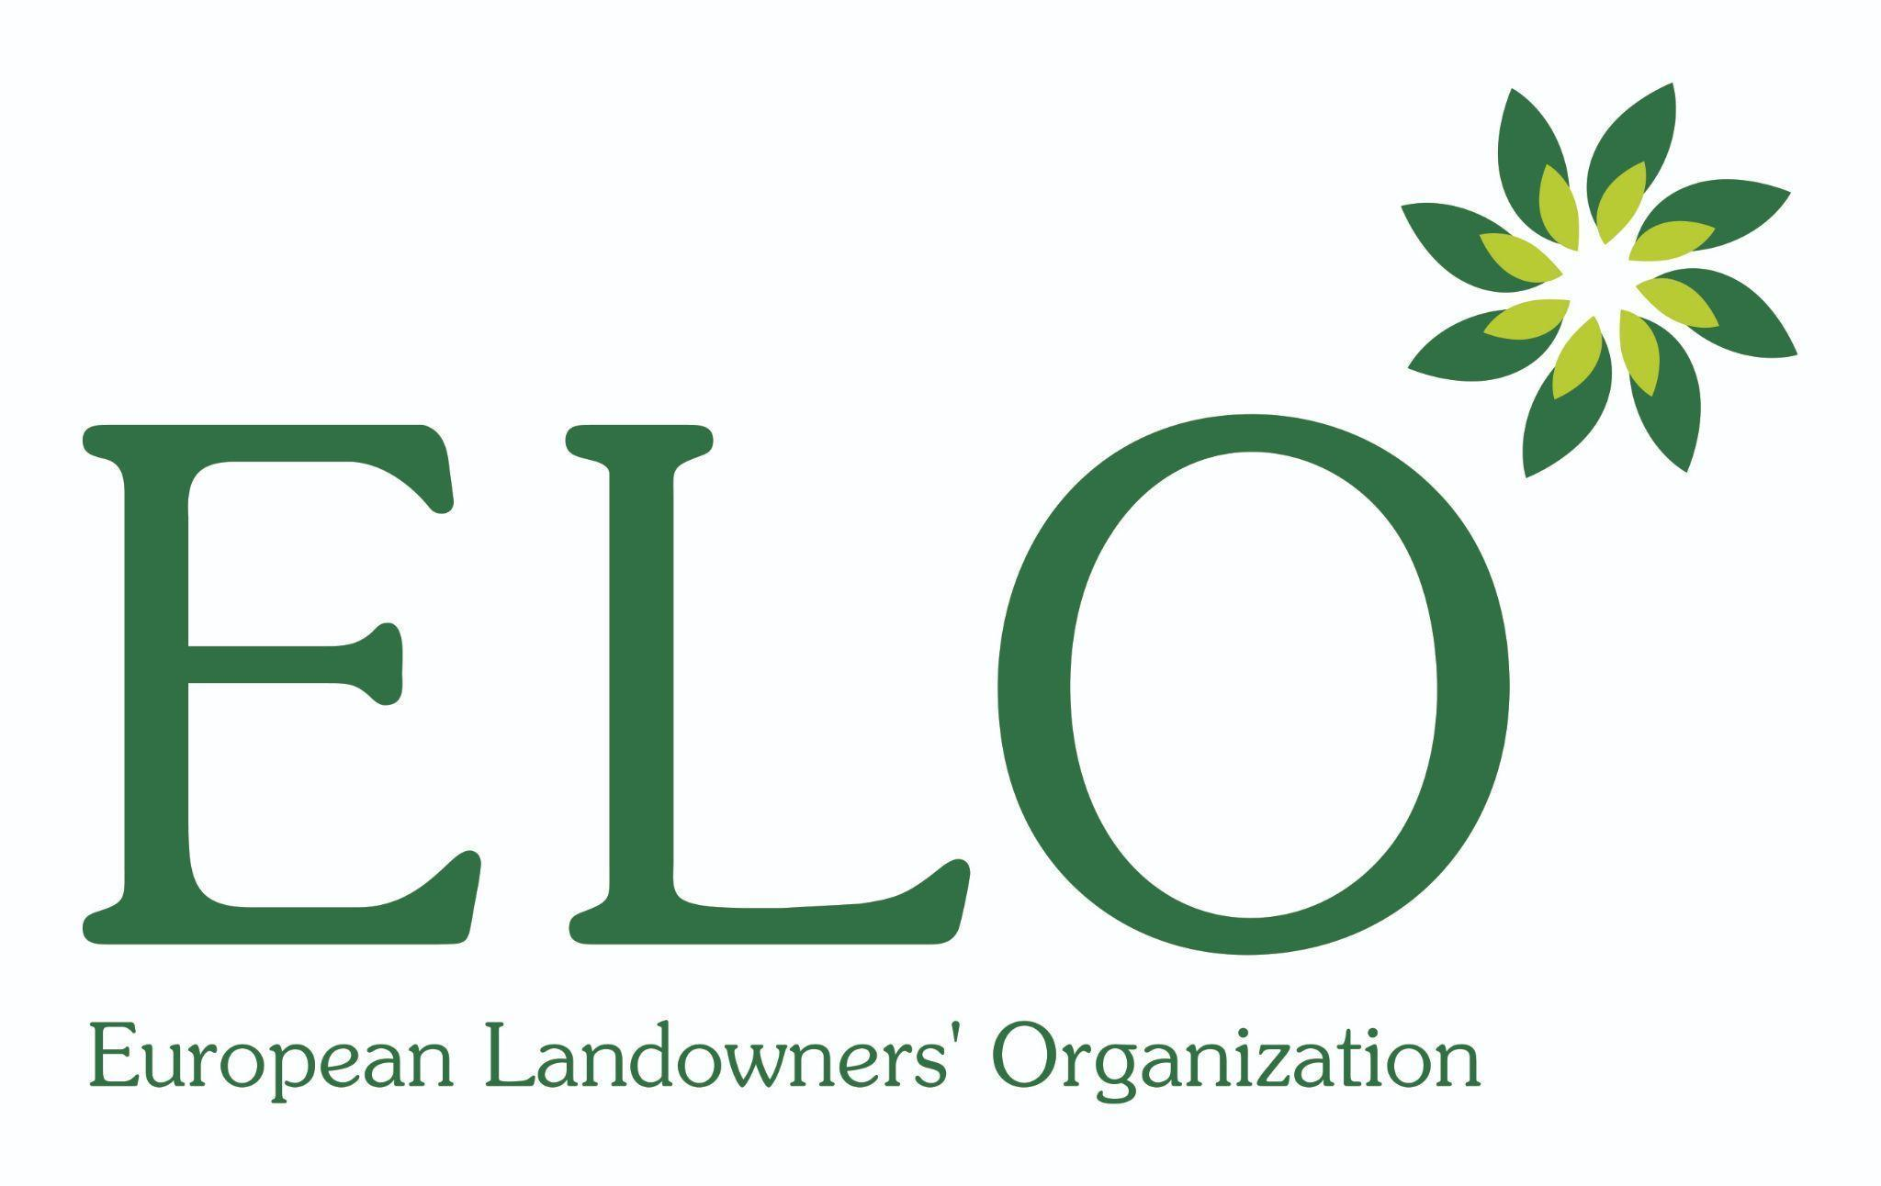

**PARTNERS OF THE CONTEST:**



**NATIONAL CONTEST ORGANISERS:**

