PRESS RELEASE

The European Tree of the Year is back in 2024 with new rules!
(BRUSSELS, February 1st, 2024) The contest seeking trees with the most interesting story which celebrates the relationship of European communities and nature is returning to the European Parliament. This year, you will be able to choose among 15 trees selected in the national rounds. The voting will be open between February 1st and February 22nd at www.treeoftheyear.org.
On Thursday February the 1st, the Environmental Partnership Association supported by the European Landowners Organisation launched the final vote in the 2024 European Tree of the Year (ETY) contest on the award's website. You will find the full list of this year’s contenders together with their stories here. The voting process sees some changes this year: the voting is open to the public from February 1st 00:00 AM CET and will run until February 22nd 4:00 PM CET. A shorter voting period was chosen to stimulate a more dynamic and intense campaign. Another novelty is that the vote counts will be hidden throughout the contest with revelations of the current standing and vote counts on February 8th and February 15th.
This year sees 15 trees from 15 communities making their case to become the European Tree of the Year. Among the organising countries we can find Ukraine for a second consecutive year. “Ever since we established the cooperation with the national organisers in Ukraine it feels like our ETY family has become a little bit more complete. We are glad to be able to continue bearing this important message,” says Adam Holub of the Czech Environmental Partnership Foundation. We also see the return of Lithuania into this year's ETY contest!
Traditionally placed in the safe hands of the co-patronage of MEPs Luděk Niedermayer (EPP) and Michal Wiezik (Renew), the Award Ceremony will take place on March 20th in the European Parliament, PAUL - HENRI SPAAK building, Floor 1, YEHUDI MENUHIN amphitheatre. Kateřina Bolečková, a co-organiser of the contest, notes the special nature of the occasion: “The Yehudi Menuhin area which we managed to secure for the evening thanks to the dedicated work of the office of MEP Luděk Niedermayer is the most prestigious space in the European Parliament. The European Tree of the Year 2024 award ceremony will take place there for the first time. It is going to be an evening to remember!”
The event comes shortly before the end of a European Parliament term which saw an ambitious environmental agenda. “Ensuring that we leave our planet in the best possible shape for our children is not just a duty for politicians but a moral responsibility for everyone. In the EP, we are committed to reducing greenhouse gas emissions by prioritising legislation that promotes the use of cleaner and more sustainable energy, while also advancing measures to protect biodiversity. Trees play a crucial role in our environment and climate. They help us adapt to climate change and retain water in the landscape. The European Tree of the Year contest goes beyond recognizing the importance of trees in our planet's ecosystem. It's a project that connects communities across Europe and brings different generations together. Through this, it sparks people's interest in the environment and the planet we call home. This is something both our nature and society truly needs,” says Luděk Niedermayer (EPP), one of the two MEP patrons of the contest.
Download the tree pictures here

Key dates:
- 1. – 22. 2. 2024: Secret voting open at www.treeoftheyear.org
- 8. 2. and 15. 2. 2024: Press releases with the current vote counts and standing
- 20. 3. 2024: Award Ceremony at the European Parliament, PAUL-HENRI SPAAK building, Floor 1, YEHUDI MENUHIN amphitheatre

Media Contacts:
Adam Holub: adam.holub@nadacepartnerstvi.cz — (+420) 777 053 722

Finalists of the European Tree of the Year 2024

Competition number | Name of the tree | Country
1 | An Oak That Remembers the Pálffy Family | Slovakia
2 | Camellia | Portugal
3 | Kaņepju Oak | Latvia
4 | Lithuania’s Patriarch Tree | Lithuania
5 | Pear Tree in the Middle of a Field | Czech Republic
6 | The Cedar of the Sainte-Marie college | Belgium
7 | The Green Lady of the "Krka" National Park | Croatia
8 | The Heart of the Garden | Poland
9 | The Maria Lime | Netherlands
10 | The Millennium Oak | Ukraine
11 | The Spanish Oak of La Vega | Spain
12 | The Thousand-year-old Olive Tree of Luras | Italy
13 | The Viiralt's Oak | Estonia
14 | The Weeping Beech of Bayeux | France
15 | Wrexham's Acton Park Sweet Chestnut | United Kingdom

The European Tree of the Year is a contest that highlights the significance of trees in the natural and cultural heritage of Europe and the importance of the ecosystem services trees provide. The contest is not looking for the most beautiful tree, but for a tree with a story, a tree rooted in the lives and work of the people and the community that surrounds it.
www.treeoftheyear.org

The Environmental Partnership Association (EPA) is a leading environmental organisation established for almost 30 years in Central and Eastern Europe. With a team of 80 employees, the EPA operates in 6 countries via its 6-member foundations in Bulgaria, the Czech Republic, Hungary, Poland, Romania and Slovakia. The EPA boasts 30-years of experience in project coordination and carrying out activities oriented to changing people’s mind-sets in order to protect and improve the environment.
www.environmentalpartnership.org

The European Landowners' Organisation (ELO), created in 1972, is a unique federation of national associations from the 27 EU Member States and beyond, which represents the interests of landowners, land managers and rural entrepreneurs at the European political level. Independent and non-profit making, the ELO is the only organisation able to stand for all rural entrepreneurs. The ELO promotes a prosperous countryside through private property dynamism. Its Secretariat is based in Brussels
www.europeanlandowners.org

THE CONTEST IS ORGANISED BY: SUPPORT:

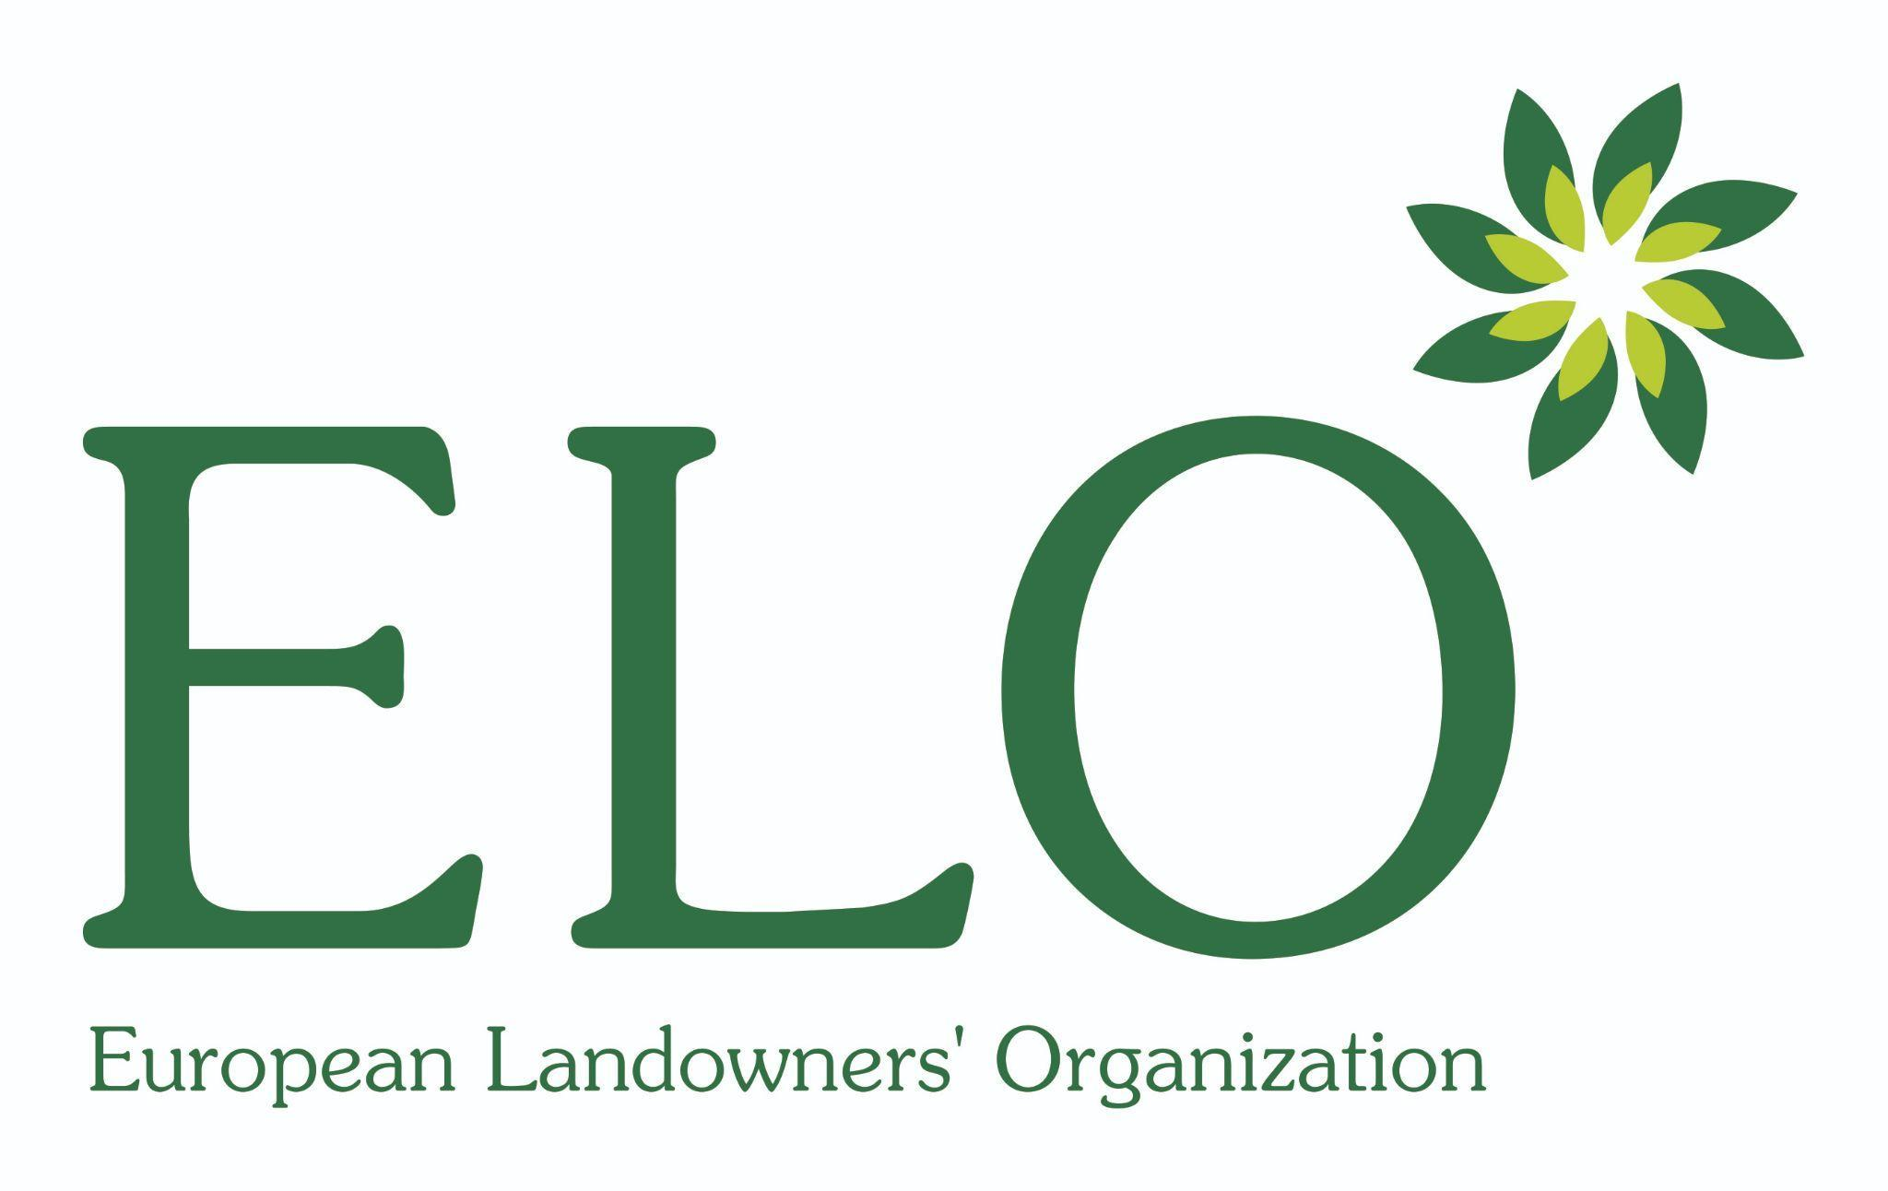

PARTNERS OF THE CONTEST:

NATIONAL CONTEST ORGANISERS:
